Tasks

## Views and routes

* Entry page – login or new user register
* Admin views - planes
  + persistent navigation – new plane button or new flight
  + new plane form - CREATE/SET - /airplanes
  + display of plane rows etc once new plane has been submitted -GET -airplanes/id
* Admin views – flights - /flights
  + new flight form - /flights - SAVE to DB
  + display of all flights once new flight has been submitted –GET /flights/index
* User views
  + search for flight – form + a SEARCH FLIGHTS FUNCTION - GET
  + search flight results – list of flights matching criteria – GET - /flights???
  + view flight – shows details of specific flight - /flight/3
  + view flight seat details – shows seat configuration PLUS which seats are available - SEAT AVAILABILITY FUNCTION. Change visual appearance of seat once it has been clicked /flight/3/seat????
  + confirm details and book – form + SET/SAVE

## Models

* Airplane
* Flight
* User
* Reservation
* Validations and conflict management
  + Server side reservation conflicts, and client/server race conditions involving reservations, can be avoided by having a validator in app/models/reservation.rb.

## Seed data

Add seed data

## Functions and actions

SEAT FUNCTIONS

SEAT NAME

How do I tell if a seat is available or not? Do I need to have something in the DB model for available?

row= [1,2,3,4]

column = [A,B,C,D,E,F, G]

need to loop through rows and columns and create a new array that concatenates each row and column

seat = row number + row name

seat = [A1,A2,A3,A4, B1,B2,B3,B4]

NUMBER OF SEATS (FOR FLIGHT CREATION)

function – how many seats in total = number of rows * number of columns

IS SEAT AVAILABLE FUNCTION??

on click add:

seat to a new array – seat taken array? OR have an id on a seat like tic tac toe? CHANGE COLOUR OF SEAT WHAT APPROACH

SEARCH FUNCTION – FIND THE FLIGHT

inputs will be where flying from (origin) and where flying to (destination) –

if origin === input AND

destination === input

return flight no

important on click actions

* from admin save – save the information to the DB
* from user search – search DB
* from users seat selection – save to DB

# User management

password protection

distinguish admin and travelers

## Look and feel and layout

*Testing*

Design

## Views and routes

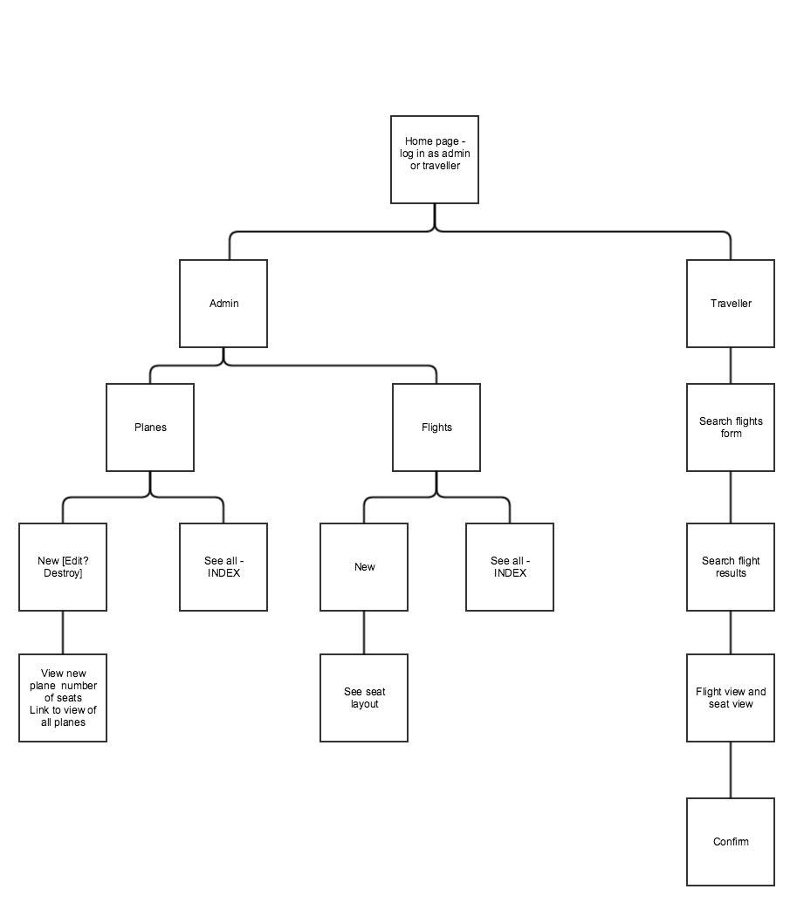

Application flow

# 1 Entry page

User selects whether Choose whether admin or user

# 2 Admin Landing page

Choose either add a flight or add a plane – *persistent navigation for an admin* – always add these

## 3 Planes - URL /airplanes page.

Design questions

* rails page or backbone to view pages

### 4 Add a plane – CREATE Method – save to DB

*Input form conncected to the DB. Needs to modify the DB when admin presses save. Save to DB – backbone functionality*

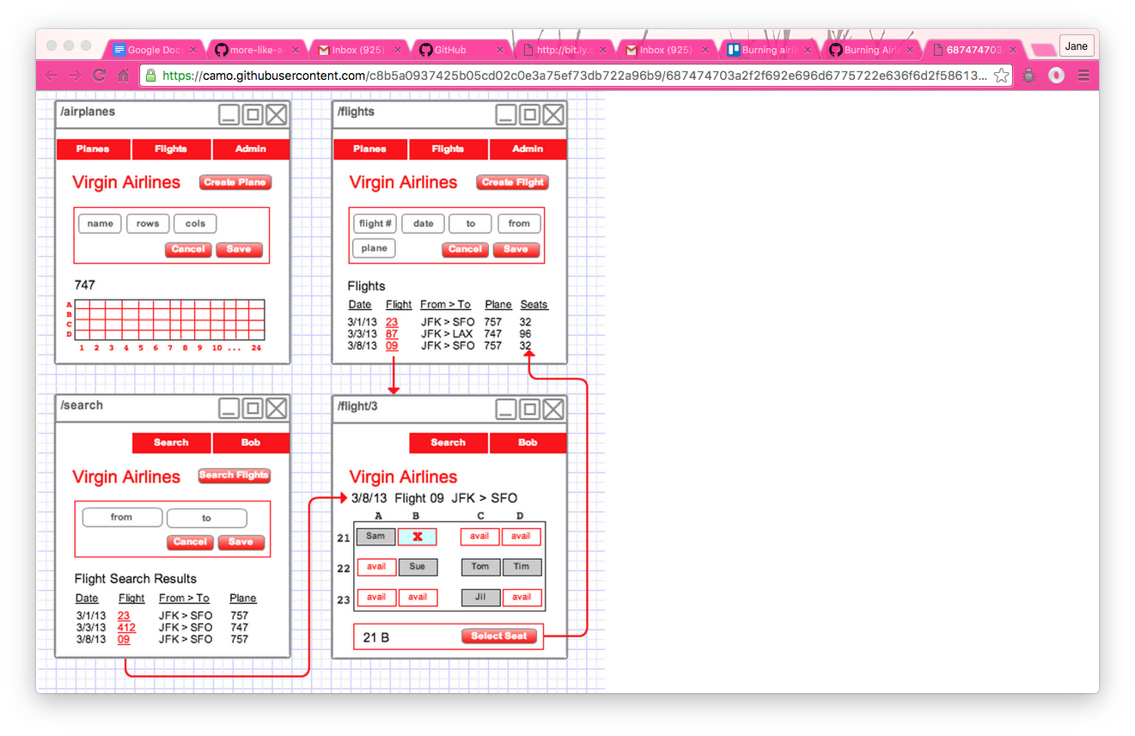

### 5 Admin clicks **save** – sees the seats on the plane

Save the data to the DB

DISPLAY the layout of the page – look back at Tic Tac Toe plane – render a BACKBONE VIEW on the page to show this?

To user display of layout, add plane name as well as type and confirm have added it

**

# flights

## 6 Admin add a flight

1. form to enter the data
2. button to submit the form

**

1. On click submit:
   1. SAVE the form to DB
   2. RENDER a list of all flights

**

## View after flight has been added

* a list of all flights with the newest date at the top of the list
* the number of available seats on the plane. SEAT AVAILABILITY FUNCTION

# USER FLOW

User login or registration

## Find flight - /search page

A user can search for flights on the /search page.

The search page should have an input form for the origin and destination.

Form for search – connected to the DB to see what flights are available

**

### Search results – link to flights –adding the NUMBER of seats available

When a user creates a search, the page should show a list of flights with the newest date at the top, and include the number of available seats on the flight. CALCULATION + POLLING FOR CHANGES TO THE NUMBER OF SEATS and the actual seats

**

function – how many seats

function – what seats

## FIND SEATS

See what seats are available _VIEW

Seat availability must be updated dynamically –FUNCTION WHAT SEATS

Select a seat – EVENT ON CLICK - as soon as clicked needs to UPDATE THE DB

**

*Once have selected a seat need user to:*

* *view the details*
* *confirm and book.*